2012 – What a Year for PMI Sydney Professional Development Team!
By Ha Nguyen, PMI Sydney Professional Development Director

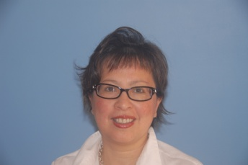
I am pleased to report that 2012 has been an excellent year for Professional Development, and rewarding and fulfilling for me personally. It has been a pleasure to work with a collaborative, involved and committed Board under Julia’s leadership and my two dedicated Associate Directors, Daniela Polit and Tracy Griffith and their teams.

Achievements include delivery of a full calendar of Short courses, Development workshops and Certification preparation classes as well as new partnerships established with CMI, IIBA providing further development and networking opportunities to our members.

We had a full curriculum for Short courses, ten were delivered this year, a total over 200 participants, with some popular courses from last year rerun and new courses such as Agile Project management, Program Management, Stakeholder Engagement and Organisation Change Management offered. Short courses have been well received by our members with excellent uptake in all, with several waitlisted! Peter De Jaeger Development interactive workshop on Change Management and Trusted Advisor relationship was a huge success with record attendance achieved. Our members have also been offered at discounted prices events and courses organised by CMI, IIBA and ACS.

Certification preparation content (150+ slide pack!) has been constantly refined and improved and nine certification preparation classes were delivered this year with a total of 82 participants. Presentations at organisations such as HP and AMP were held to promote benefits of certification. Well done to several members who received certification exam after attending these preparation classes. The organisations’ presentations have also generated a lot of interest.

Late October, I had the opportunity to attend the PMI Leadership Institute Meeting (LIM) and the Global Congress in Vancouver, Canada.
The LIM and Congress featured outstanding Mark Langley, PMI President and CEO, who talked about trends that organisations are pursuing to gain competitive advantage, and the growing recognition from organisations of portfolio management, benefit and value concepts of projects, organisational agility, talent development, and new skills required in PMs. Technical skills are essential but in this new world but are no longer enough, as executives are demanding PMs to have leadership, soft skills, as well as strategic and business management skills, a broader and more business driven focus. A Project manager is no longer ‘just a project manager’ but a Business Consultant, Trusted Advisor and Change Agent.

Our development offering for next year will definitely take these insights into consideration as well as exploring other delivery channels such as webinars and online training. Watch this space!

Thank you for your support this year and special thanks to my Associate Directors Daniela Polit and Tracy Griffith and their teams namely Greg Franks, Arti Malhorta, Chi Nguyen, Jiankai Yin and Sudipto Mukherjee in their tireless dedication and effort in making this happen. We are looking forward to an exciting 2013 culminating with the PMI Australian Conference in May and what promises to be an exciting year ahead with full of development and growth opportunities for our members.

